Experiment 1: Observation of Mitosis in a Plant Cell
In this experiment, we will look at the different stage of mitosis in an onion cell. Remember that mitosis only occupies one to two hours while interphase can take anywhere from 18 - 24 hours. Using this information and the data from your experiment, you can estimate the percentage of cells in each stage of the cell cycle.

Materials
Onion (allium) Root Tip Digital Slide Images

Procedure:
Part 1: Calculating Time Spent in Each Cell Cycle Phase
- The length of the cell cycle in the onion root tip is about 24 hours. Predict how many hours of the 24 hour cell cycle you think each step takes. Record your predictions, along with supporting evidence, in Table 1.
- Examine the onion root tip slide images on the following pages. There are four images, each displaying a different field of view. Pick one of the images, and count the number of cells in each stage. Then count the total number of cells in the image. Record the image you selected and your counts in Table 2.
- Calculate the time spent by a cell in each stage based on the 24 hour cycle:
Hours of Stage = | 24 x Number of Cells in Stage
 | Total Number of Cells Counted
Part 2: Identifying Stages of the Cell Cycle
- Observe the images of the root cap tip.
- Locate a good example of a cell in each of the following stages: interphase, prophase, metaphase, anaphase, and telophase.
- Draw the dividing cell in the appropriate area for each stage of the cell cycle, exactly as it appears. Include your drawings in Table 3.
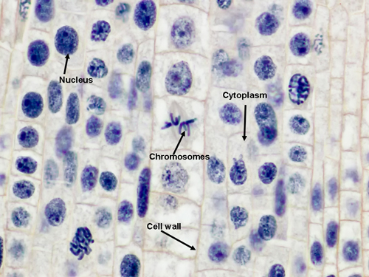
Onion Root Tip: 100X

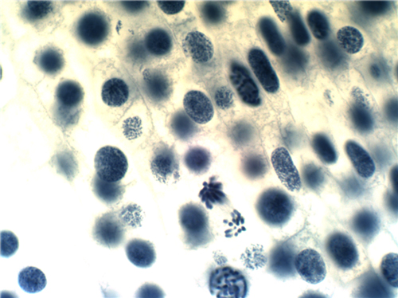
Onion Root Tip: 100X

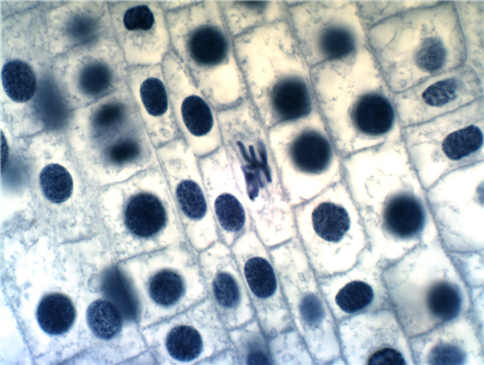
Onion Root Tip: 100X

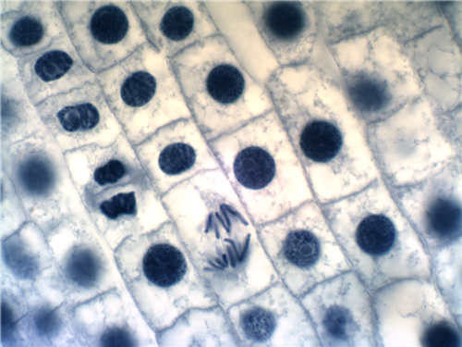
Onion Root Tip: 100X

Table 1: Mitosis Predictions
Predictions:
Supporting Evidence:

Table 2: Mitosis Data
Number of Cells in Each Stage | Total Number of Cells | Calculated % of Time Spent in Each Stage
Interphase: |  | Interphase:
Prophase: |  | Prophase:
Metaphase: |  | Metaphase:
Anaphase: |  | Anaphase:
Telophase: |  | Telophase:
Cytokinesis: |  | Cytokinesis:

Table 3: Stage Drawings
Cell Stage: | Drawing:
Interphase:
Prophase:
Metaphase:
Anaphase:
Telophase:
Cytokinesis:

Post-Lab Questions
- Label the arrows in the slide image below with the appropriate stage of the cell cycle.
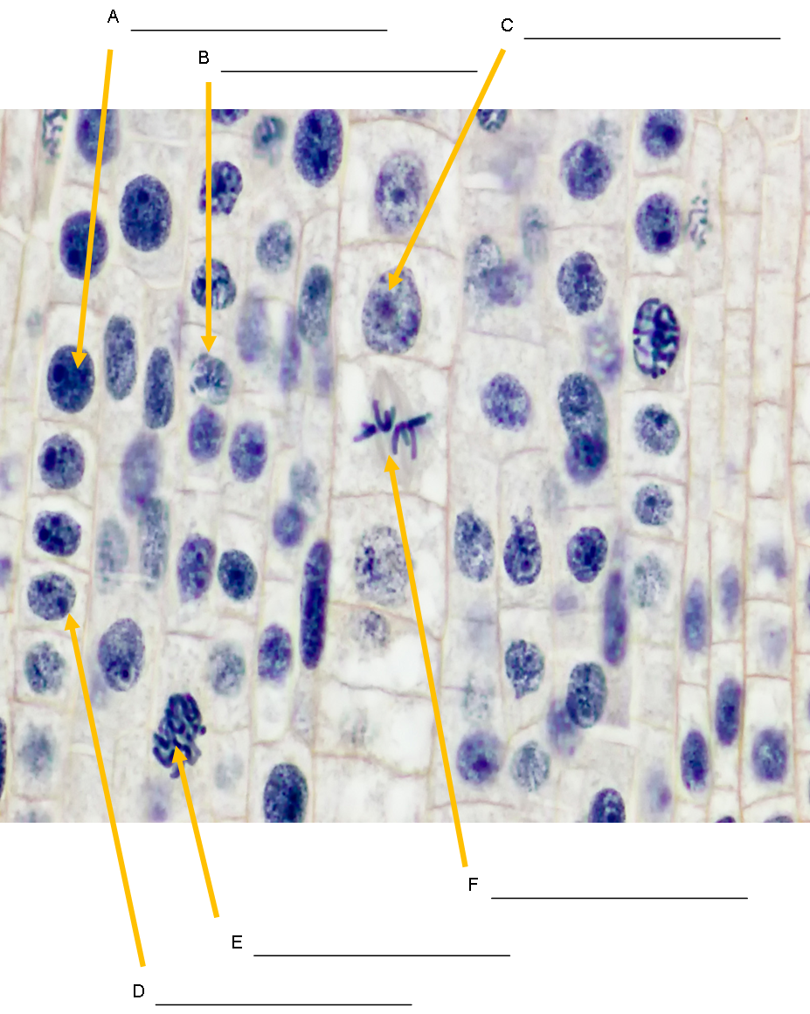

- In what stage were most of the onion root tip cells? Based on what you know about cell cycle division, what does this imply about the life span of a cell?

- Were there any stages of the cell cycle that you did not observe? How can you explain this using evidence from the cell cycle?

- As a cell grows, what happens to its surface area to volume ratio? (Hint: Think of a balloon being blown up). How does this ratio change with respect to cell division?

- What is the function of mitosis in a cell that is about to divide?

- What would happen if mitosis were uncontrolled?

- How accurate were your time predication for each stage of the cell cycle?

- Discuss one observation that you found interesting while looking at the onion root tip cells.

